Information Security Investments by Small Businesses in AWS

Theresa Kann

Information Technology, Metropolitan Community College

INFO 2085: Network and Information Security Basics

Professor Gary Sparks

May 14, 2021

Abstract

Small businesses (SBs) must provide the same data security as large corporations when handling sensitive data even though they do not have the same training budget or human capital resources to apply to information security. This paper considers the use of a Cloud Services Provider (CSP) for SBs to conduct business with the same level of information security as large corporations. The research will help SB Owners gain a better understanding of necessary information security protocols and how to evaluate the CSP, Amazon Web Services (AWS), security product offerings. Additionally, the research clarifies the level of investment in training and staff allocations needed to provide robust information security by using AWS.

Keywords: information security, cloud computing security, cloud service provider,

disaster recovery in the cloud, data protection, data privacy

Information Security Investments by Small Businesses in AWS

The U.S. Small Business Administration (SBA) defines Small Business (SB) by revenue from $1 million to $40 million and by employment from 100 to 1,500 employees with the majority having the legal structure of partnership or sole proprietorships (Hait, 2021). There are 30.7 million SBs in the U.S. which account for 99.9 percent of all U.S. businesses and employ 59.9 million people, which is 47.3 percent of the U.S. private workforce (Small Business Statistics, n.d.). These statistics drive cyberattacks on SBs - most businesses with data valuable to cybercriminals are SBs. Another important statistic to cybercriminals is 43% of small to medium-sized businesses lack any type of cybersecurity defense plans (Crane, 2020, What section, para. 3).

More than half of small to medium-sized businesses have been breached in the past 12 months, 38% of companies that experienced a breach lost more than 20% of revenues, while 40% lost more than 20% of their customers (Baldridge, 2020). SBs work with the same personal information identifiers that cybercriminals seek in large corporations, but “lack the security infrastructure of larger enterprises” (Bowcut, 2021, Section Small businesses). The people who run and work at SBs face unique challenges in information security. SB Owners prioritize where to spend their time since they fulfill multiple roles which results in not having enough time or expertise applied to cybersecurity. Even though the amount of data may be small, cybercriminals see small businesses as targets due to easily obtained data and as attack vectors to larger corporations that they are vendors for (Bowcut, 2021).

Most information security attacks are in two categories: malware and social engineering with “97 percent of cyber threats include some element of social engineering” (Bowcut, 2021, Section Cyber). “Another concern is ransomware in cloud-based technology. Any company or individual who has information stored on cloud technology could be at risk if hackers get access to the cloud and hold that data hostage.” (Baldridge, 2020, para. 3) The resulting situation is approximately 43% of the businesses in the U.S. lack the training and tools to defend against malware, ransom attacks, and social engineering threat attacks.

One way SBs can mitigate the risk of cyberattacks is use a Cloud Services Provider (CSP) and its information security protocols. “For small and mid-sized organizations, use of well-established, mature CSPs helps reduce risk associated with transitioning applications and data to the cloud” (Faatz, 2018, Section Looking Ahead, para. 2). The marketplace leader is Amazon Web Services (AWS). If a SB does not have the financial resources or human capital capacity to maintain an Information Security department, they can evaluate the cost-benefit of using AWS’s services for business processes to provide sufficient information security infrastructure. A SB needs to evaluate whether using AWS as a CSP can offer the SB’s customers the highest level of information security at a reasonable investment of training and staff allocations to the SB.

Small Business uses of AWS

“The very advantages that such cloud offerings provide to large corporations can also be used by smaller shops: low-cost computing resources, the ability to scale quickly and a platform-agnostic approach” (Business News Daily Editor, 2020). Following are the categories of services AWS provides to its customers.

Software as a Service (SaaS)

The customer uses the vendor’s applications that are made available through the cloud. A thin interface allows consumers to access applications through consumer units.

Platform as a Service (PaaS)

The customer creates, executes and maintains applications over the cloud. Programming languages and tools are made available by the vendor.

Infrastructure as a Service (IaaS)

The vendor provides the clients with computing resources to facilitate essential activities such as processing, storage and connectivity to build and operate software.

Storage as a Service (StaaS)

StaaS is a subset of IaaS that allows customers to store their data remotely in a manner that keeps it easily and instantly accessible. Effective cloud storage is crucial in order to address many key deliverables such as: substantial availableness, trustworthiness, overall performance, replication, and data regularity.

Disaster Recovery as a Service (DRaaS)

Technological advances and innovations along with robust systems and high speed connections have made it imperative for organizations to engineer operational models that can be quickly restored. Zero downtime is the business fraternity’s ultimate goal (Cloud, n.d., paras. 11-15).

Each of these services has security, training and staff allocation implications for the SBs. The SB must understand the AWS Shared Responsibility Model of security, the skills employees need to fulfill the customer responsibilities and the type of staff allocations needed.

Shared Responsibility Model for Information Security

AWS uses a shared responsibility model for security processes which means AWS solely owns some security processes, other processes are shared utilities between the AWS and the Business and other processes are complete responsibility of the Business (Faatz, 2018). AWS Academy (n.d.) explains the shared responsibility model as:

Under the AWS shared responsibility model, AWS operates, manages, and controls the components from the bare metal host operating system and hypervisor virtualization layer down to the physical security of the facilities where the services operate. Customers retain control of what security they choose to implement to protect their own data, environment, applications, Identity Access Management (IAM) configurations, and operating systems (ps. 6-7).

In Figure 1, the upper blue section shows the Customer’s responsibilities and the lower orange section shows AWS’s responsibilities. The AWS shared responsibility model is commonly referred to as AWS is responsible for security “of” the cloud and the customer is responsible for security “in” the cloud (AWS Academy, n.d., p. 5).

Figure 1

AWS Shared Responsibility Model for Security

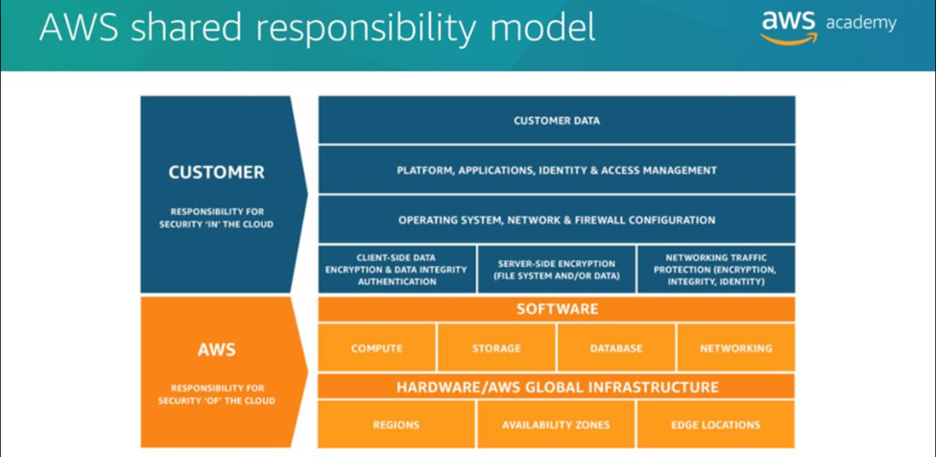

Small Business Implementation Plan for Information Security in AWS

Stephen Pritchard sums up the result of information security planning for SBs: “Ultimately, only the business knows which data to protect – and how much they will pay to do so…” (Speak section, para. 3). When a SB creates an Information Security plan, including a Disaster Management System (DMS), it needs to know the recovery point objective (RPO) – how much data a business can afford to lose, and the recovery time objective (RTO) – how long a business can wait for data to be recovered (Pritchard, 2021, Cloud DR section, para. 1). Figure 2 shows the Disaster Recovery (DR) techniques, these also apply to information security, which the SB Owner must either train an employee or know herself if the tasks will be done in-house.

Figure 2

Data Management System (DMS) 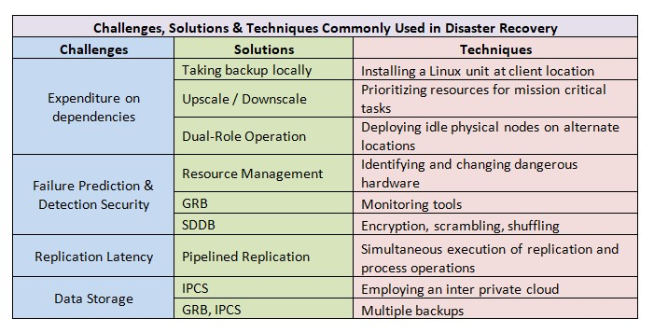

Note: This information would be in a DMS with the objective of reviving critical applications after an incident (Cloud DR section, para. 4).

Training for Employees

Small business owners need to invest in cybersecurity and not react to an incident. Since all small businesses are at risk to being targeted by cybercriminals, even modest training and infrastructure improvements are a good investment (Alton, 2020). AWS offers a full suite of training classes through the AWS Academy at aws.amazon.com/training/awsacademy/. Moving IT operations to AWS requires employees learn the AWS system in addition to managing on-premises infrastructure. Areas that add complexity are key management, encryption services, monitoring, and implementation methods (Morrow, 2018).

A training course for working with AWS needs to cover these topics: visibility of data, regional data locations and regional attack protections, data redundancies, encryption and key management, data restoration after crash or attack, security protocols and certifications, implementation risks, reseller responsibilities (Martins, 2020). Additional training for employees working in the AWS Shared Responsibility Model focuses on having reduced visibility and control, protocols for unauthorized use of on-demand services, API vulnerabilities in the management plane, failure of separation between multiple tenant environments, and complete data deletion over different storage devices (Morrow, 2018).

This type of training from the Small Business Cybersecurity Corner on the NIST website is an example of training needed:

Free cybersecurity training for Small Businesses from non-profits Global Cyber Alliance and Cyber Readiness Institute. Begins April 14, 2021. Register here https://gcatoolkit.org/cyber-basics-for-small-businesses-training/ (Small Business Cybersecurity Corner, 2021)

Staff Allocations for Information Security Job Responsibilities

If a SB determines that using AWS is the best alternative to implement their information security plan, the SB will need to train or hire a Cloud Engineer. A Cloud Engineer will need these 6 skills: CSP architecture, storage, networking, virtualization, Linux, and security and disaster recovery (Padghan. 2020). The skills can be obtained via a college degree, through industry certifications or by self-study. The information security plan must account for how the SB will obtain the necessary skills to operationalize their business in AWS.

Implications of Moving a SB to the AWS Cloud on the Information Security and DMS

SBs can operate at the level of large corporations when it comes to information security and DR by operationalizing their business in the AWS Cloud. Threat actors are targeting SBs with on-premises operations, hoping they are not doing due diligence with their data protection and data privacy protocols. The impact of a cyberattack could be much greater on a SB since the response and recovery resources are usually limited.

There is no difference in the information security and DR plan between on-premises or AWS when it comes to the SB Owner knowing the RPO and RTO of the data generated by the business. Any SB must categorize the type of data it generates and stores and know the type of data protection and data privacy protocols it is willing to pay for.

To successful defend against cyberattacks in AWS, the SB Owner must account for skills needed beyond on-premises information security and DR. The SB Owner has options to either learn these skills herself, hire a Cloud Engineer, or outsource the work needed. The first option is very time intensive, and the second and third options are expensive. These are decisions the SB Owner needs to make before engaging with AWS. There are many benefits of running a SB in the AWS Cloud, but they do not come without thorough understanding for the information security training and staff allocation needed to work with the AWS Shared Responsibility Model for Security.

References

Alton, L. (2020, December 3). The 8 Best Cybersecurity Strategies for Small Businesses in 2021. Inc. https://www.inc.com/larry-alton/the-8-best-cybersecurity-strategies-for-small-businesses-in-2021.html

AWS. (n.d.). Smart Business. AWS. https://aws.amazon.com/campaigns/smart-business/

AWS Academy. (n.d.). Module 4 AWS Cloud Security. AWS. https:// https://aws.amazon.com/training/awsacademy/

Business News Daily Editor. (2020, February 18). What Small Business Owners Need to Know About AWS. Business News Daily. https://www.businessnewsdaily.com/10581-aws-small-business-features.html

Bowcut, S. (2021, February 24). Cybersecurity guide for small business. cybersecurity GUIDE. https://cybersecurityguide.org/resources/small-business/
Cloud Computing for Disaster Recovery and Business Continuity Solutions (n.d.). disasterrecovery.org DR. https://www.disasterrecovery.org/cloud-computing-for-disaster-recovery-business-continuity/

Crane, C. (2020, December 9). 15 Small Business Cyber Security Statistics That You Need to Know. Hashedout by The SSL Store. https://www.thesslstore.com/blog/15-small-business-cyber-security-statistics-that-you-need-to-know/
Faatz, D. (2018, March 12). Best Practices for Cloud Security. Software Engineering Institute
[Web log post].
https://insights.sei.cmu.edu/sei_blog/2018/03/best-practices-for-cloud-security.html

Martins, A. (2020, November 6). Cloud Computing: A Small Business Guide. Business News Daily. https://www.businessnewsdaily.com/4427-cloud-computing-small-business.html

Mohsin, M. (2020, December 3). 10 Small Business Statistics Every Future Entrepreneur Should Know in 2021. OBERLO. https://www.oberlo.com/blog/small-business-statistics
Morrow, T. (2018, March 5). 12 Risks, Threats, & Vulnerabilities in Moving to the Cloud. Software Engineering Institute. https://insights.sei.cmu.edu/blog/12-risks-threats-vulnerabilities-in-moving-to-the-cloud/

Hait, A. (2021, January 19). What is a Small Business? United States Census Bureau. https://www.census.gov/library/stories/2021/01/what-is-a-small-business.html

Padghan, V. (2020, November 25). Skills You Should Learn To Become A Cloud Engineer. Edureka! https://www.edureka.co/blog/skills-you-should-learn-to-become-a-cloud-engineer/

Pritchard, S. (2021, January 6). Five Key Points about Cloud vs In-house Disaster Recovery. ComputerWeekly.com. https://www.computerweekly.com/feature/Five-key-points-about-cloud-vs-in-house-disaster-recovery

RSI Security. (2019, August 2). How to Build an Information Security Plan for Your Small Business. https://blog.rsisecurity.com/how-to-build-an-information-security-plan-for-your-small-business/
Small Business Cybersecurity Corner. (2021, April 16) Training. NIST.
https://www.nist.gov/itl/smallbusinesscyber
Small Business Disaster Recovery in the Cloud. (n.d.). DisasterRecovery.
https://www.disasterrecovery.org/small-business-disaster-recovery-in-the-cloud/
Small Business Statistics. (n.d.). Small Business Trends. https://smallbiztrends.com/small-business-statistics
Straight Edge Technology. (n.d.). 7 Top Cybersecurity Threats For Businesses In 2021 [& how to prevent them]. Straight Edge Technology. .https://www.straightedgetech.com/5-top-cybersecurity-threats-and-their-solutions-for-2020/

